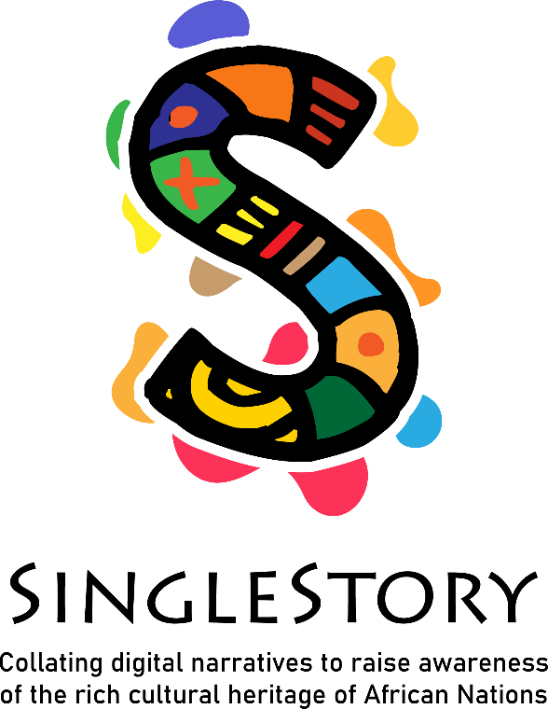
IO1 – Digital Storytelling Curriculum
Module 2

IO1 – Digital Storytelling Curriculum

Module 2

Module Title: | Me as a storyteller
Title of Activity: | Video: “Using African history as a tool for Change”
Duration of Activity: | 30 minutes
Why use this resource? | In this activity, the learners will see an inspirational video about the history of Africa.  They will also recognise how storytelling can share a sense of history, values, and traditions. The art and techniques of storytelling. They will learn that stories can promote intercultural understanding and communication among people. Also, they will see how body language is essential to pass a message.
What will you get from using this resource? | With these activities learners will be able to explore their stories, different styles of storytelling, how to be a good speaker and find their own voice as a storyteller. In addition, they will learn to use their stories to sensitise others and show a different way to look at Africa and africans.
Link to Additional Resources or Reading Materials: | Source: Marks, S. (2019). Southern Africa. In Encyclopædia Britannica. https://www.britannica.com/place/Southern-Africa  ‌
References/ Sources: | Source: Zeinab Badawi. (2017). Using African history as a tool for Change. In TED. https://www.ted.com/talks/zeinab_badawi_using_african_history_as_a_tool_for_change

